Criteria Rating Form, Weighted Ranking

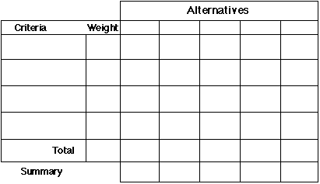
Use the criteria rating form when:
- You have to select among several alternatives
- You want to make a decision objectively
- You want your group to agree on a decision

1. Start the session and list the alternatives available

2. Brainstorm decision criteria
You will be judging your alternatives against what you feel are the most important qualities each one should have. These qualities are called decision criteria. Brainstorming may be a useful way for a group to agree appropriate criteria.

3. Determine the relative importance of each criterion.
Rank the criteria and assign a relative importance (weight) to each. The total of the assigned weights should equal 100.

4. Establish a rating scale; rate the alternatives.
A suitable rating scale might be, for instance: 1= low, 10=high. each alternative should be weighed against each criterion, using the same scale for each.

5. Calculate the final score.
Multiply the weight for each alternative by the score and write this in brackets. Add up the numbers in brackets for each alternative and write the sums in the appropriate total boxes. Add any summary comments in the appropriate summary box.

6. Select the best alternative.
Select the alternative with the highest score. this alternative may not be the one ultimately chosen - if the group disagrees with the choice, they should review the weighting of the criteria and make the necessary changes. if necessary, repeat the process.

References
- Chang, RY., and Niedzwiecki, ME., "Continuous Improvement Tools", Volume 1. 1993, 1995. Kogan Page Ltd. London

